ATTACHMENT B – LOCALITY PLAN
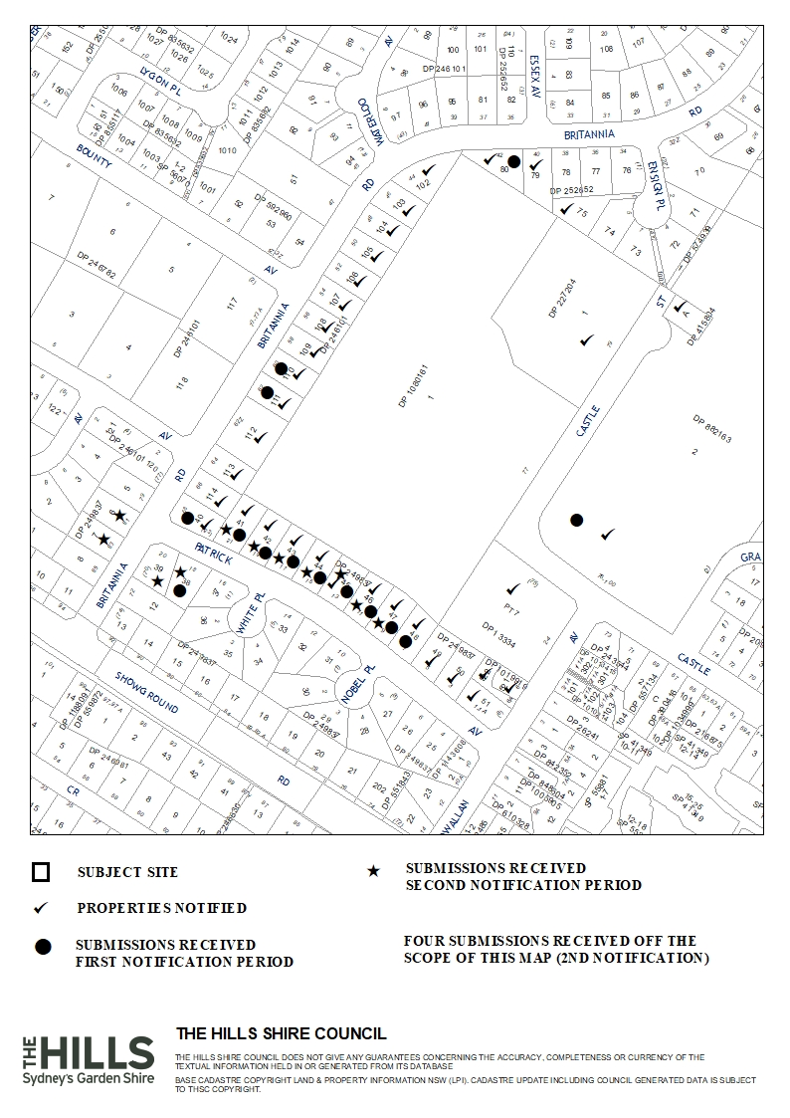

ATTACHMENT C – AERIAL MAP
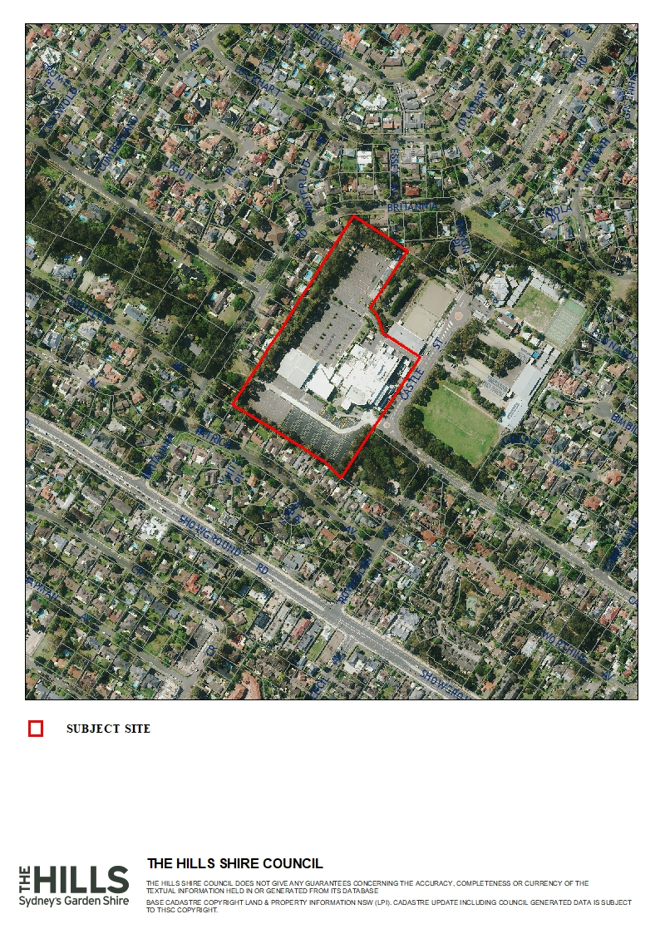

ATTACHMENT D – ZONING MAP

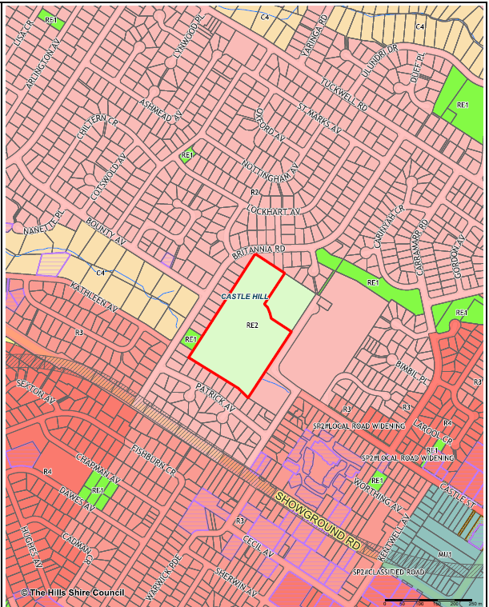
ATTACHMENT E – SITE PLAN

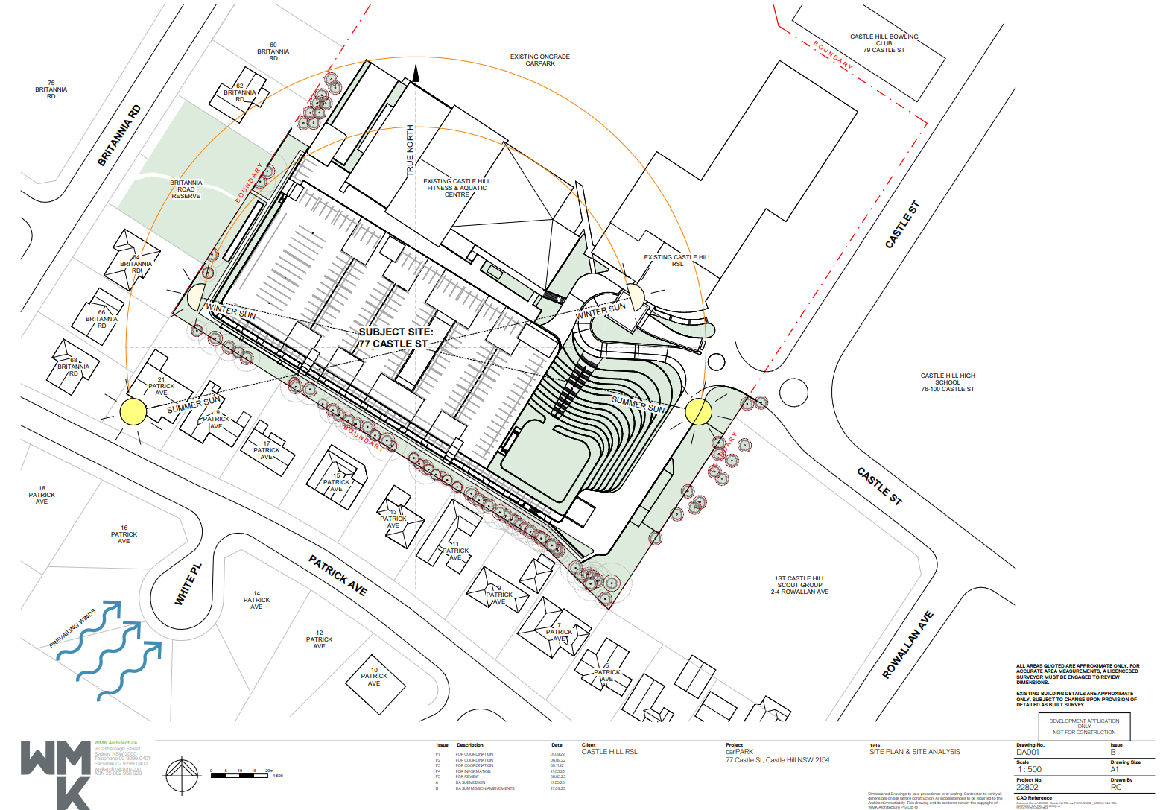
ATTACHMENT F – FLOOR PLANS (3 PAGES)

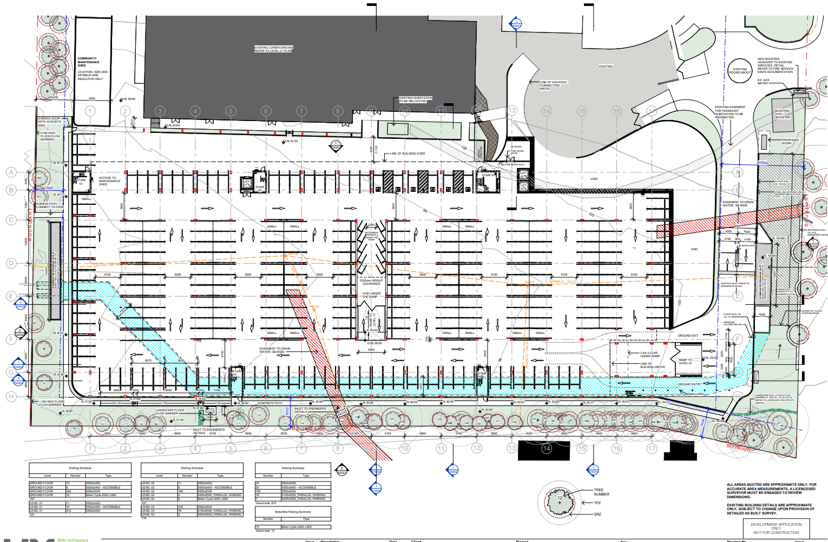
GROUND FLOOR

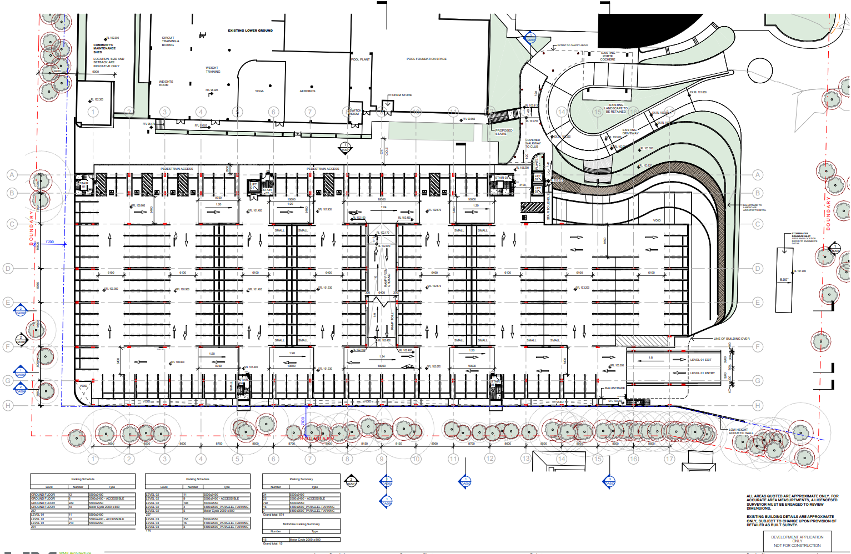
LEVEL 1

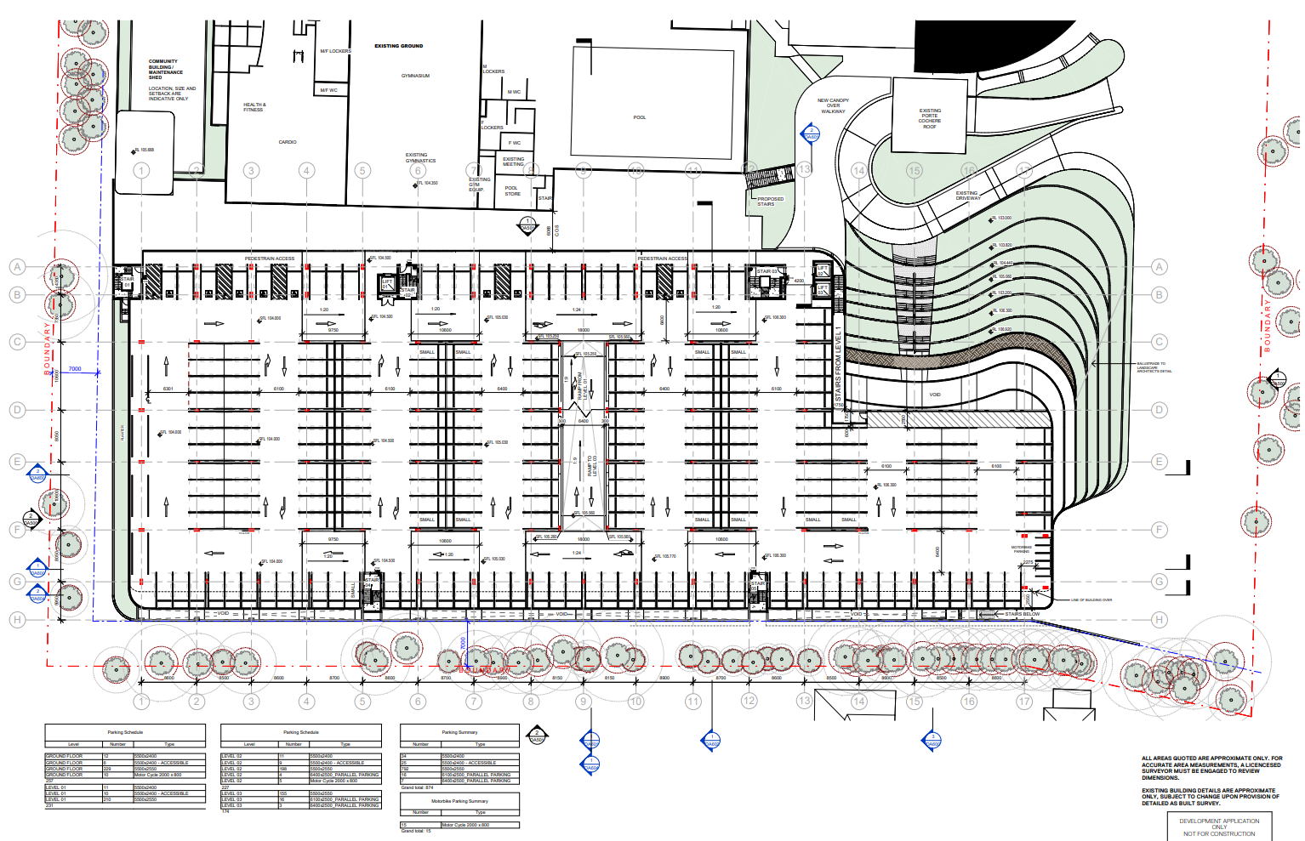
LEVEL 2

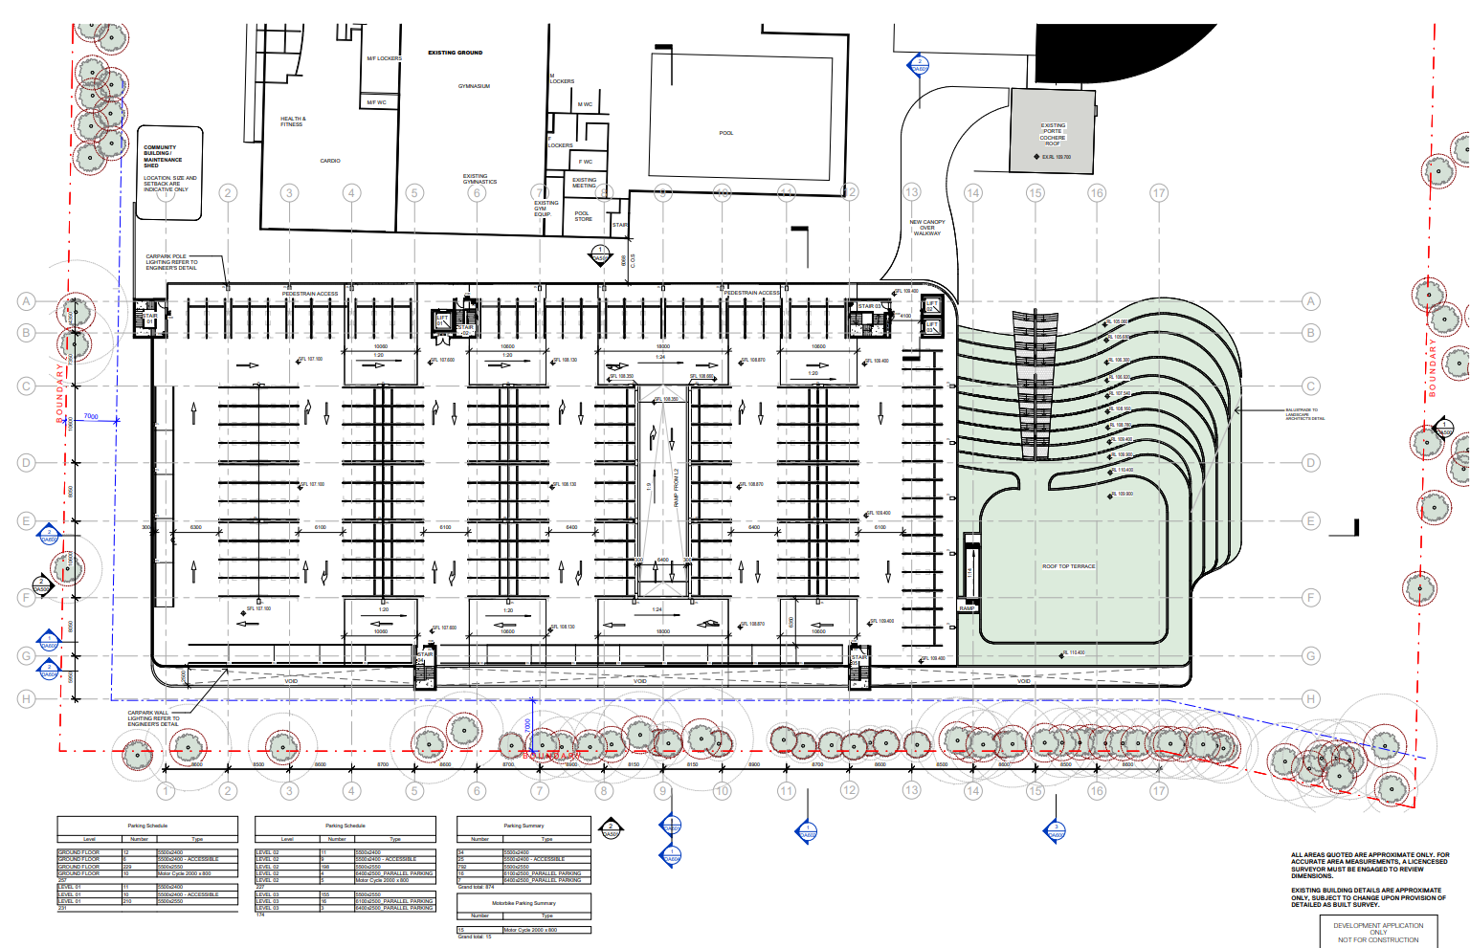
LEVEL 3

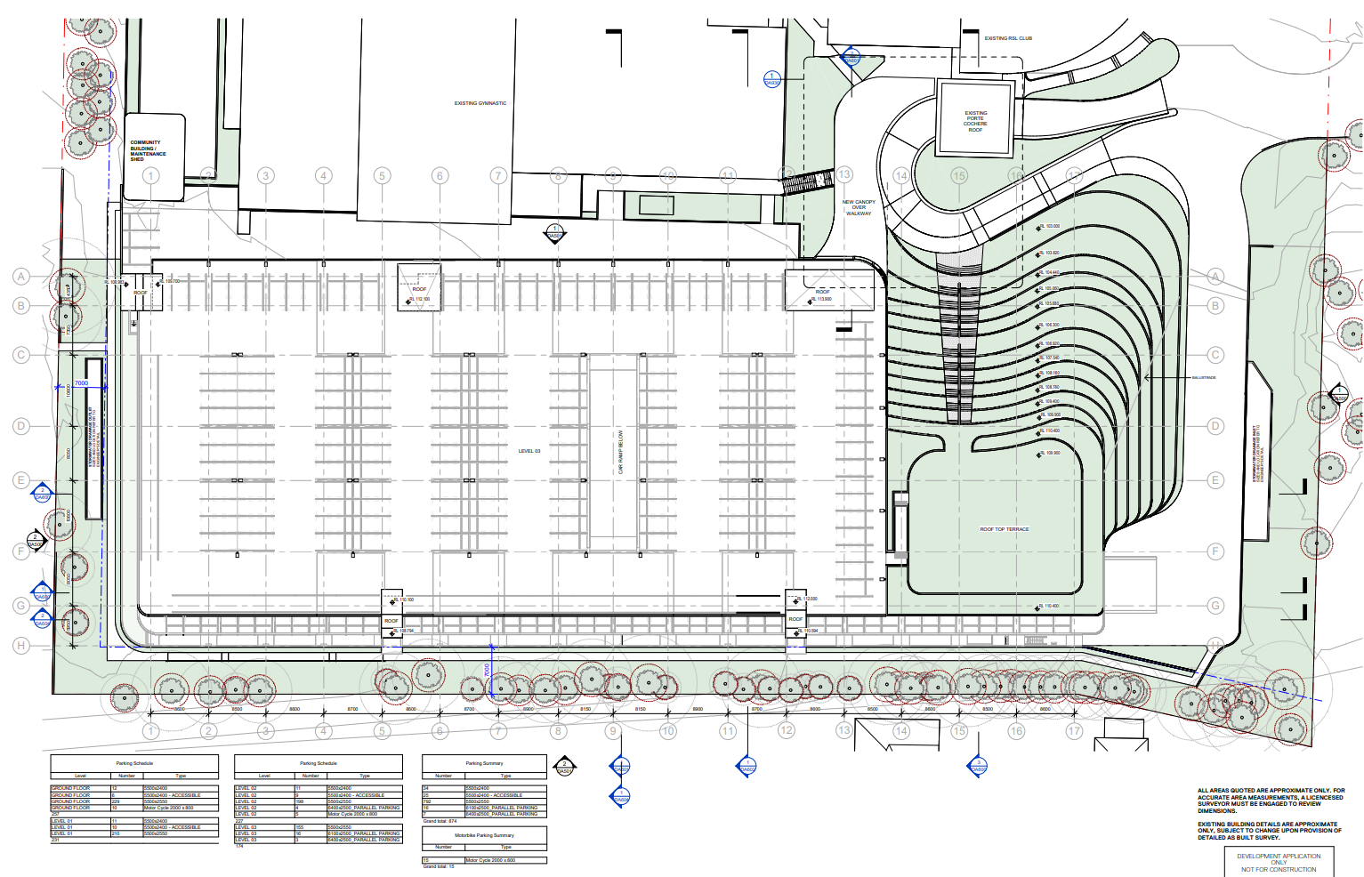
LEVEL 4
ATTACHMENT G – ELEVATIONS

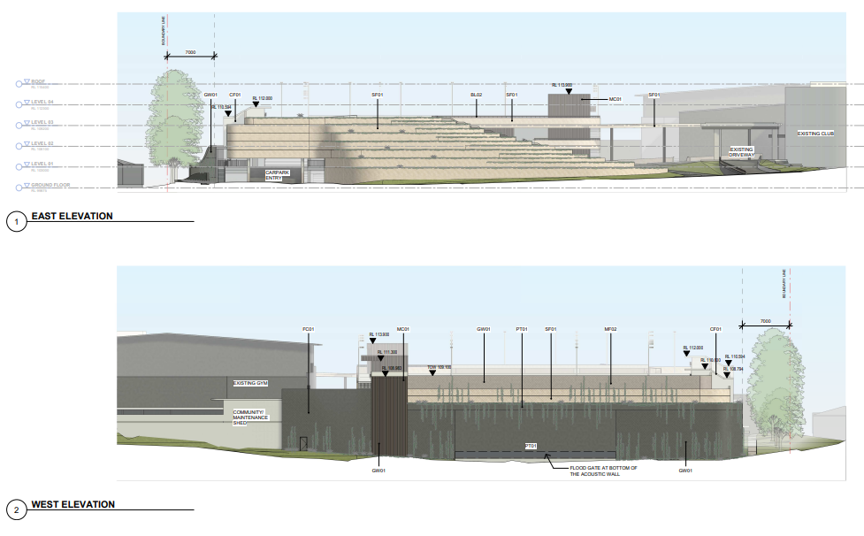

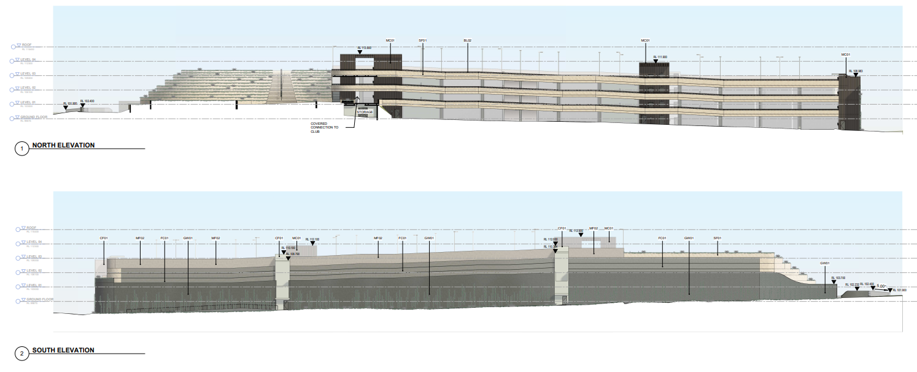
ATTACHMENT H – SECTIONS

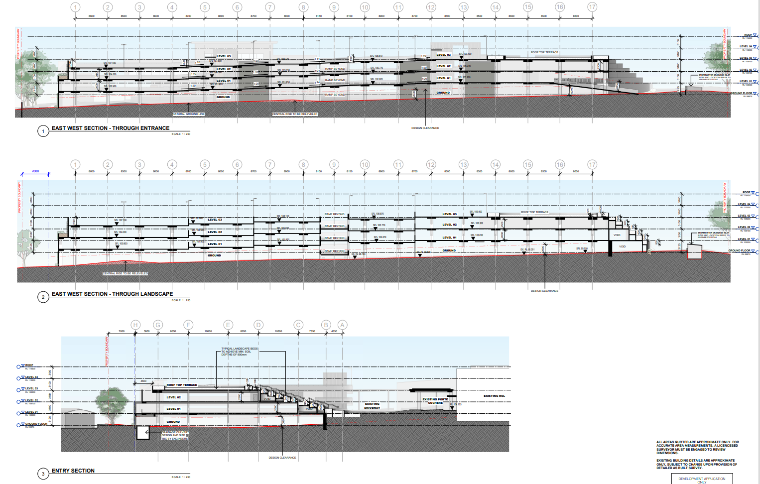

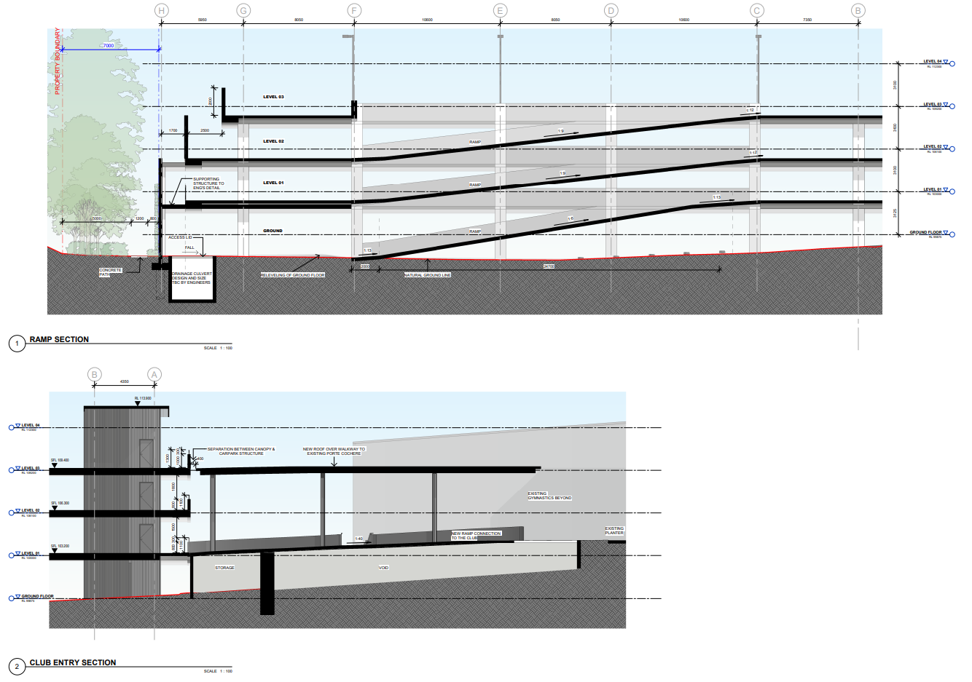

ATTACHMENT I – ACOUSTIC BUFFER & NEIGHBOUR INTERFACE

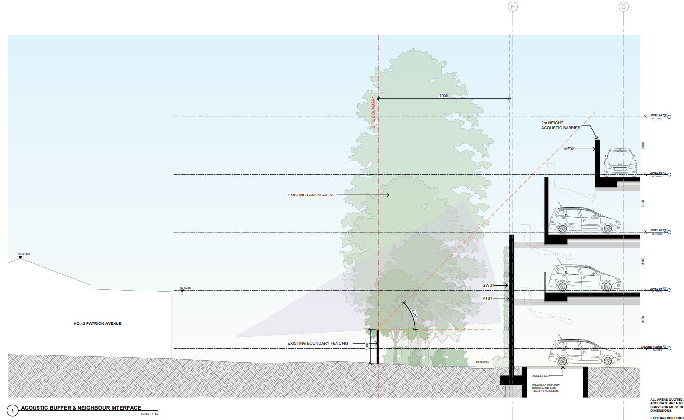

ATTACHMENT J – BUILDING HEIGHTS FOR EACH SETBACK AT EACH PROPERTY
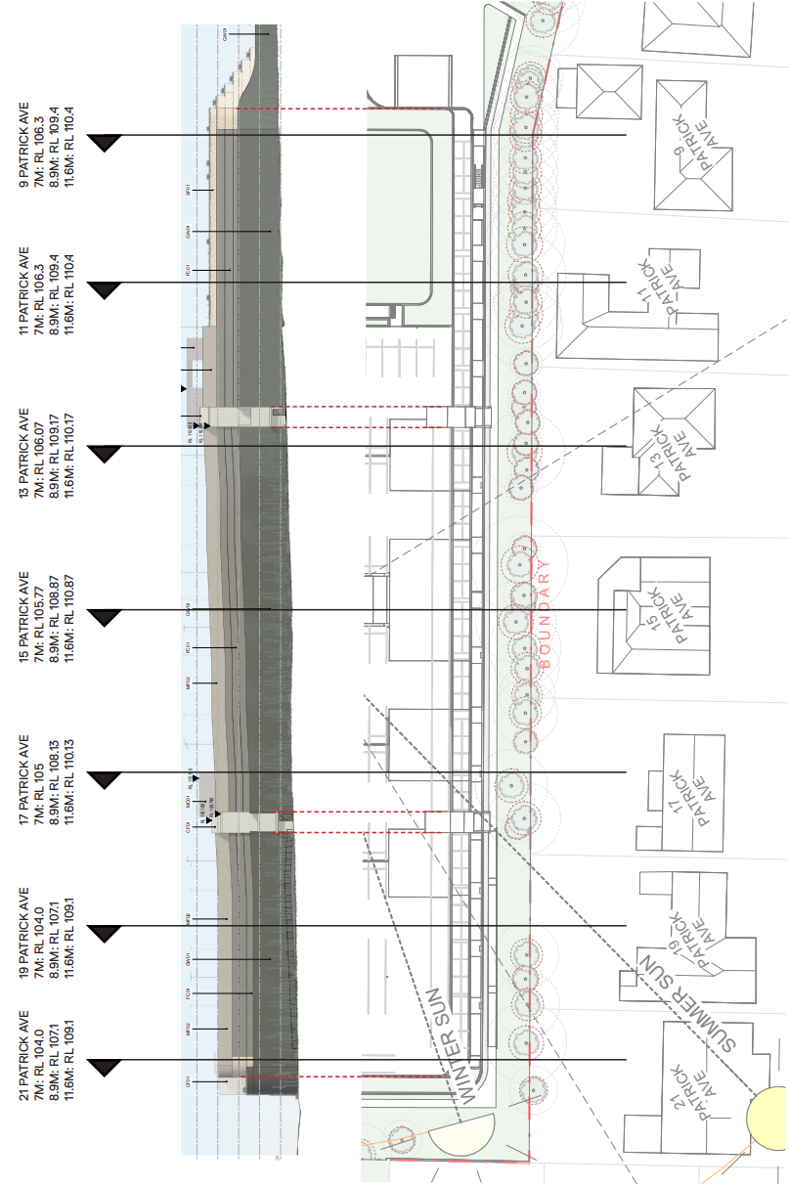
ATTACHMENT K – MID-WINTER SHADOW DIAGRAMS (3 PAGES)

JUNE 21ST – 9AM

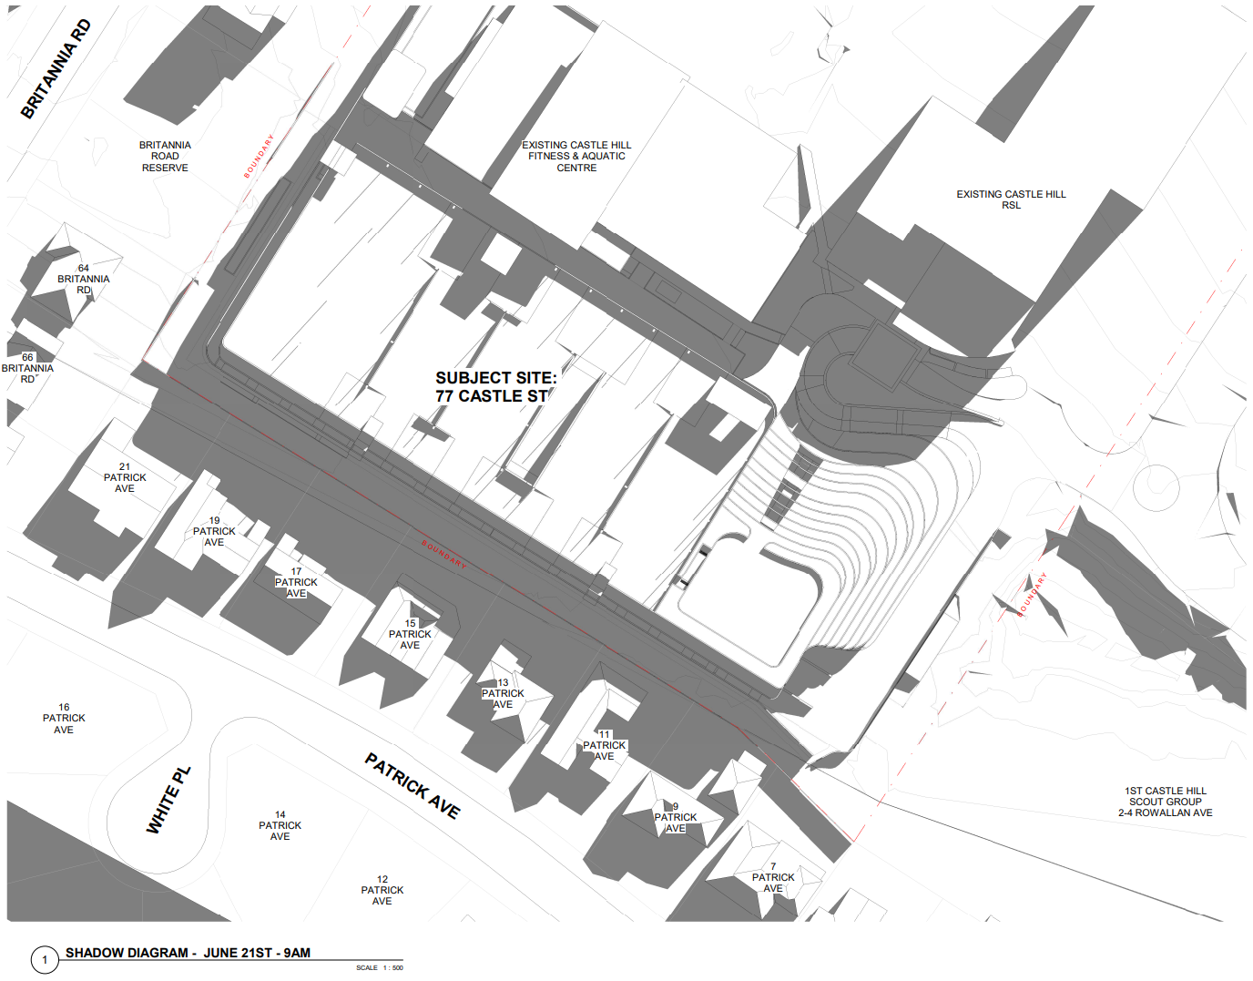

JUNE 21ST - 12PM

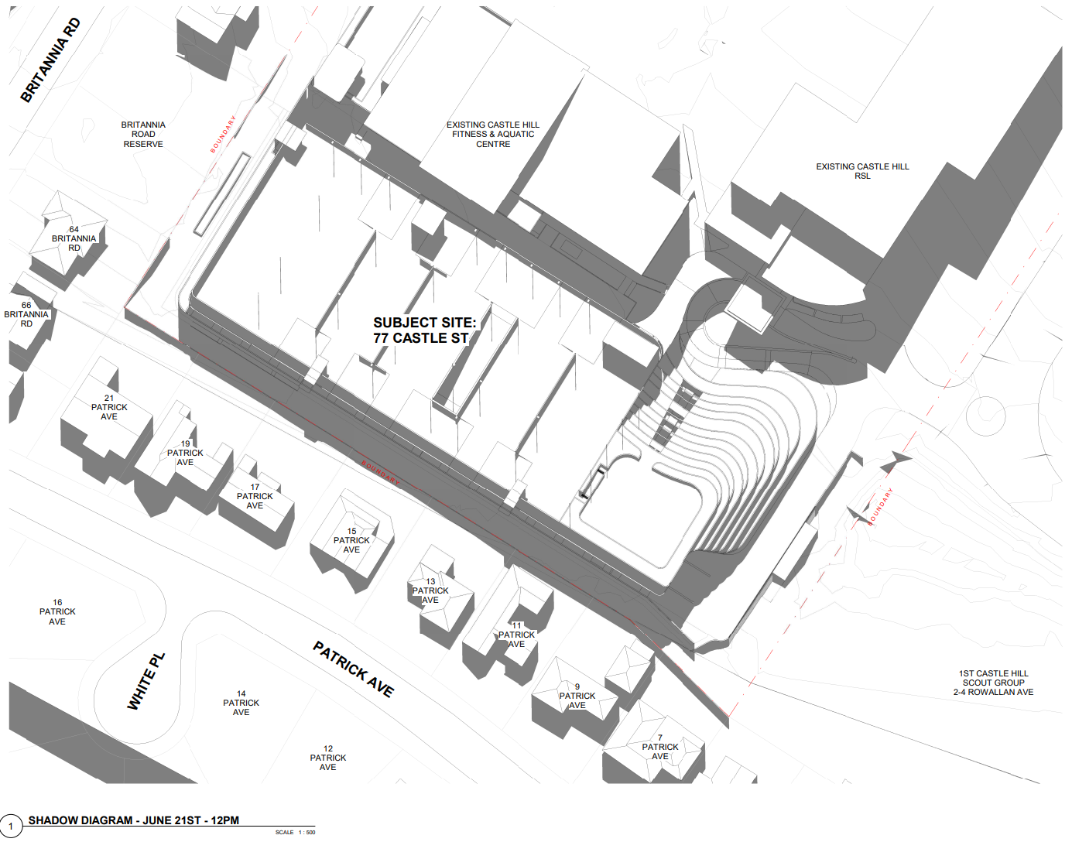

JUNE 21ST – 3PM

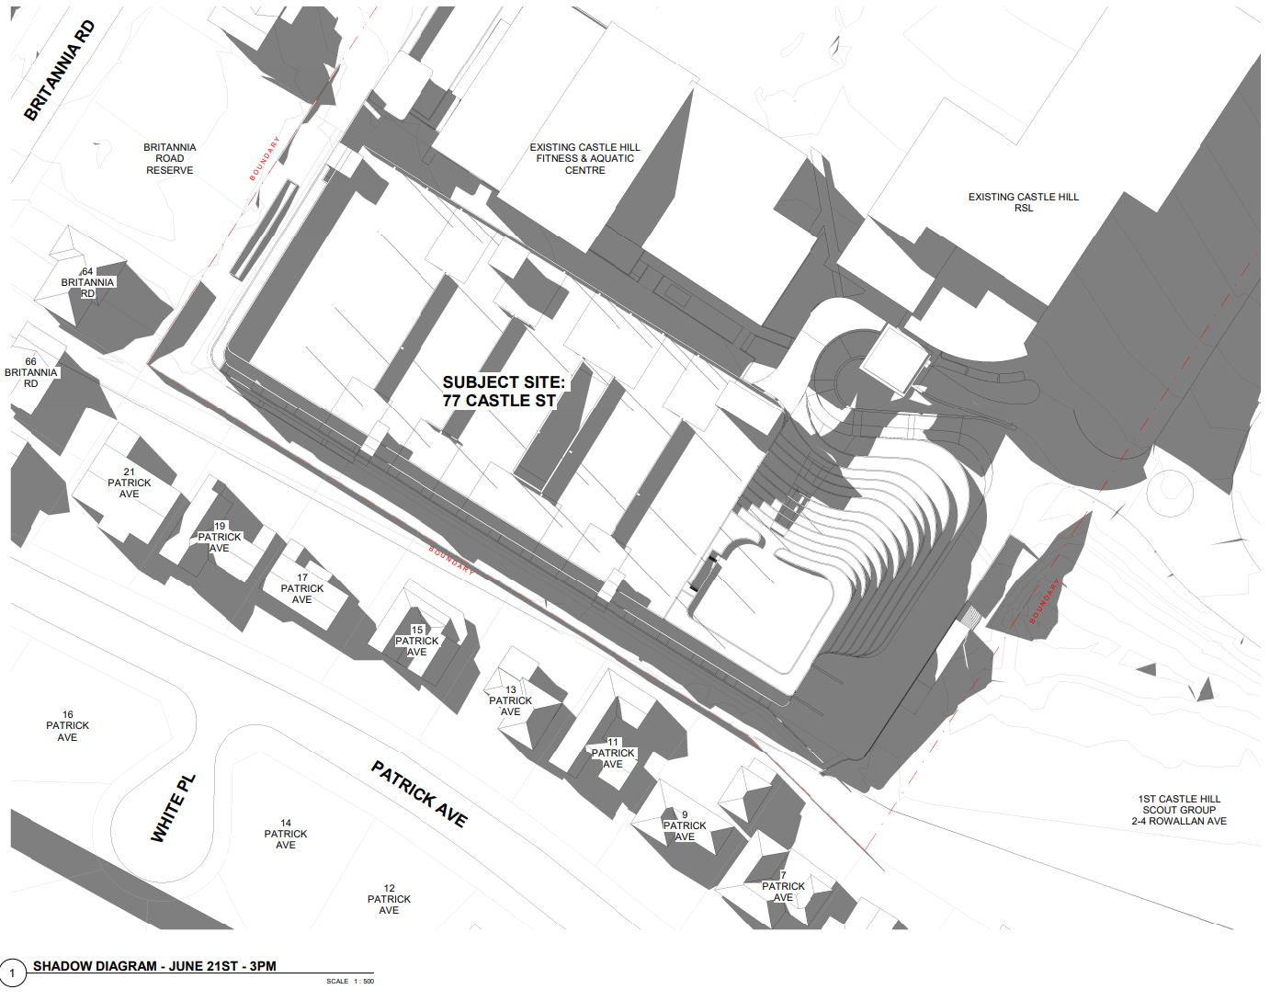

ATTACHMENT L – VISUAL IMPACT IMAGES (3 PAGES)

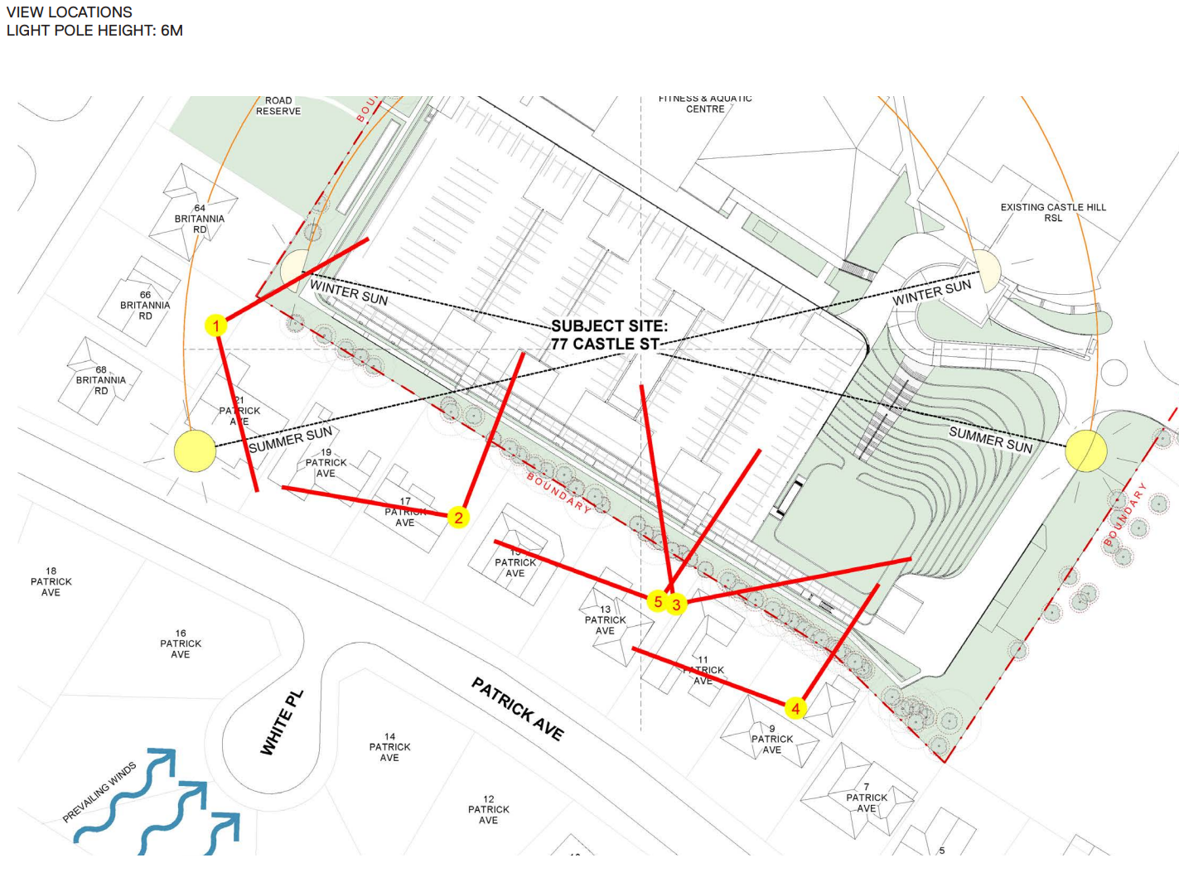

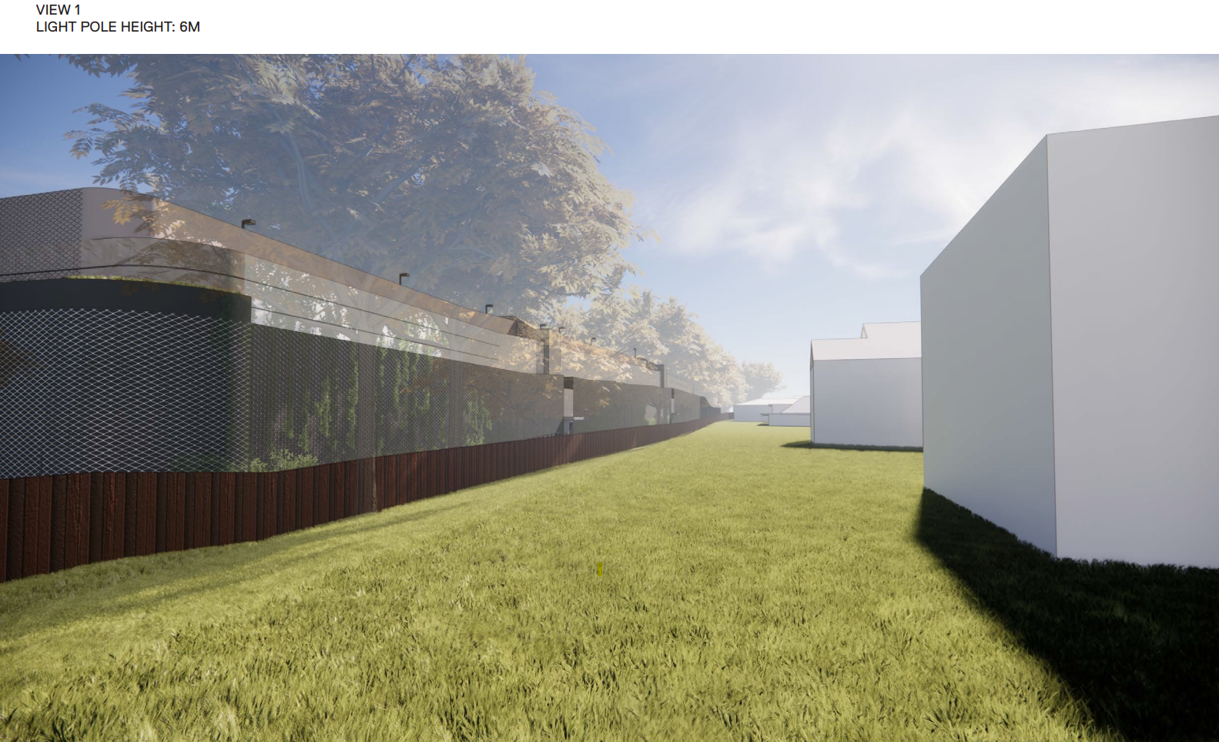

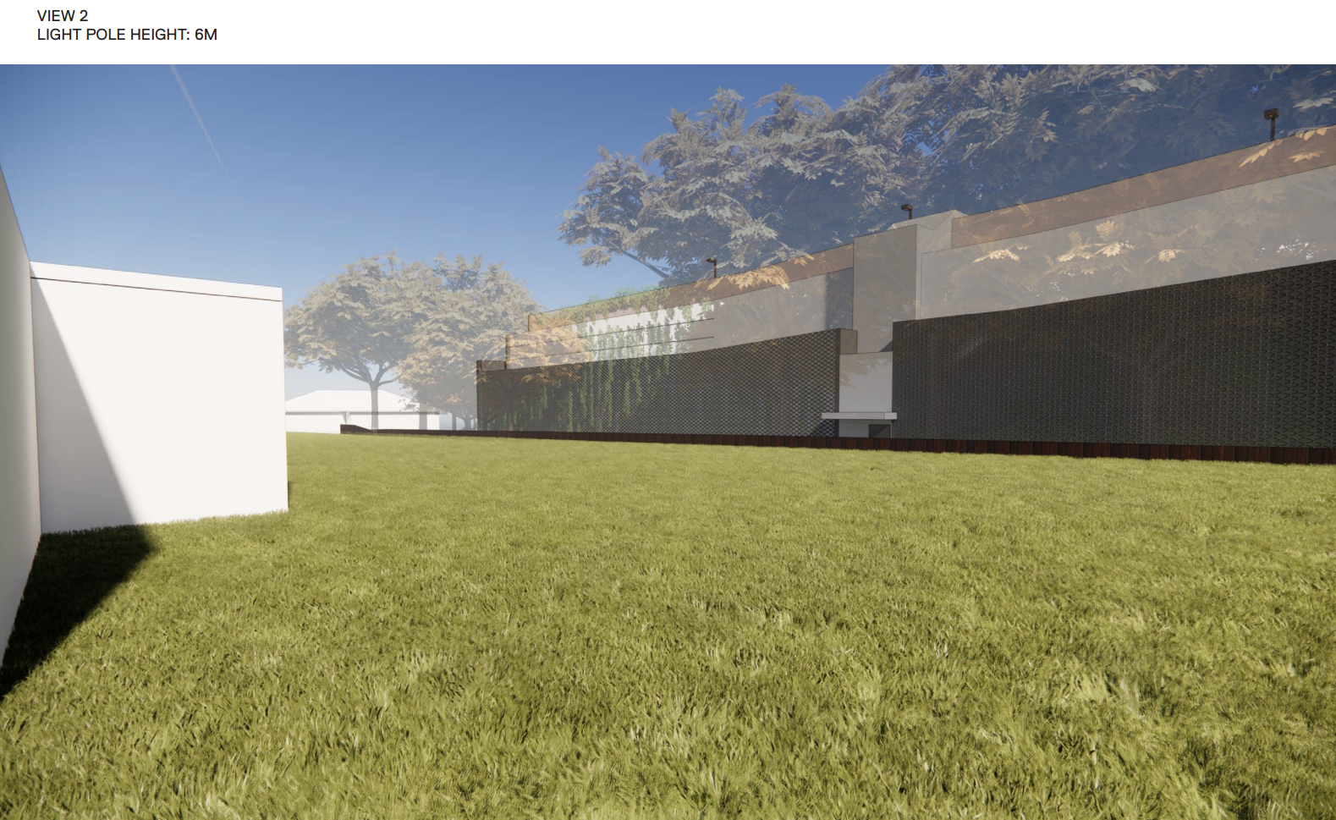

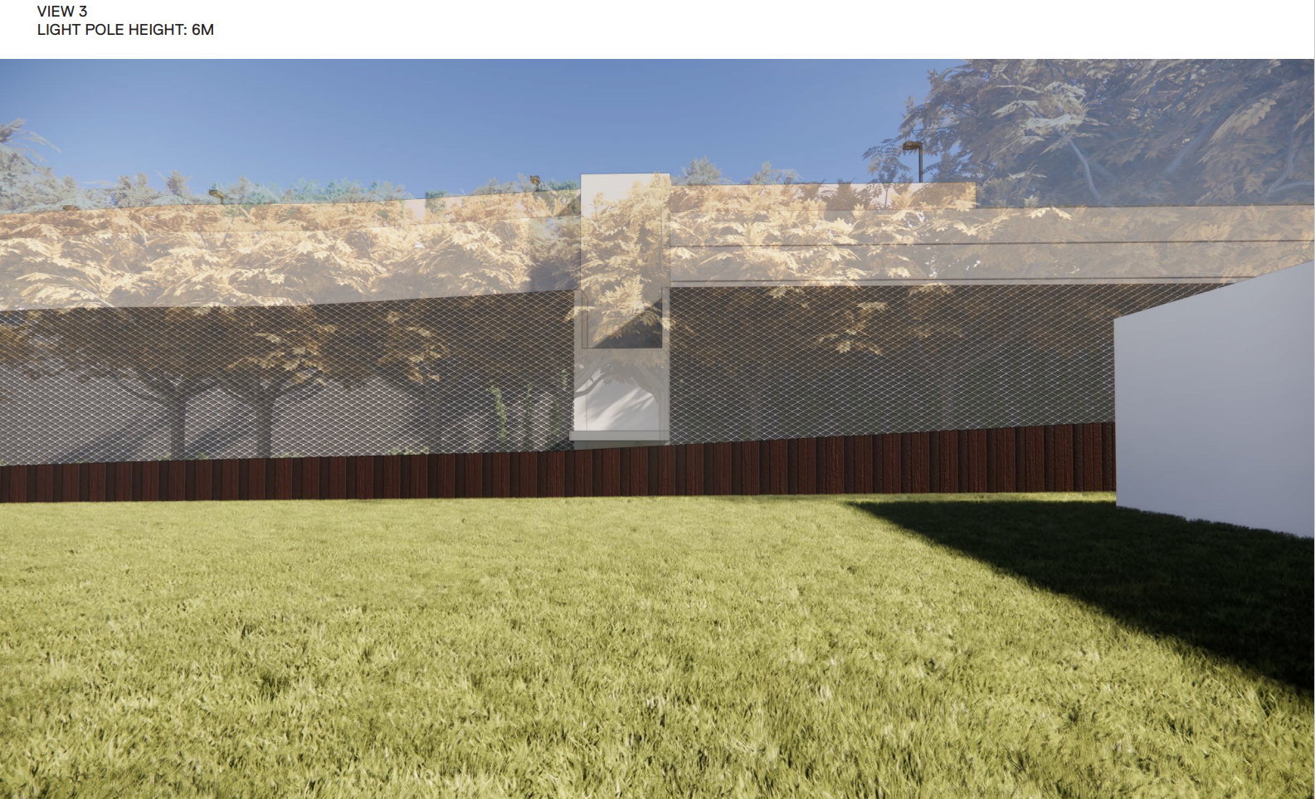

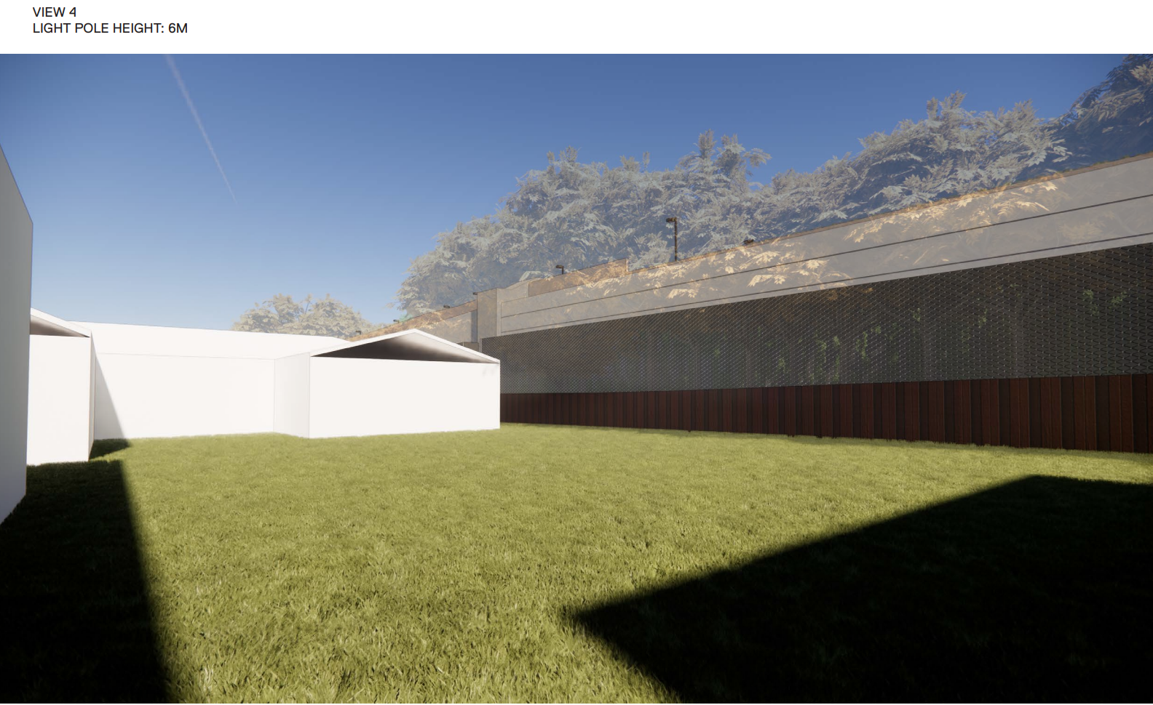

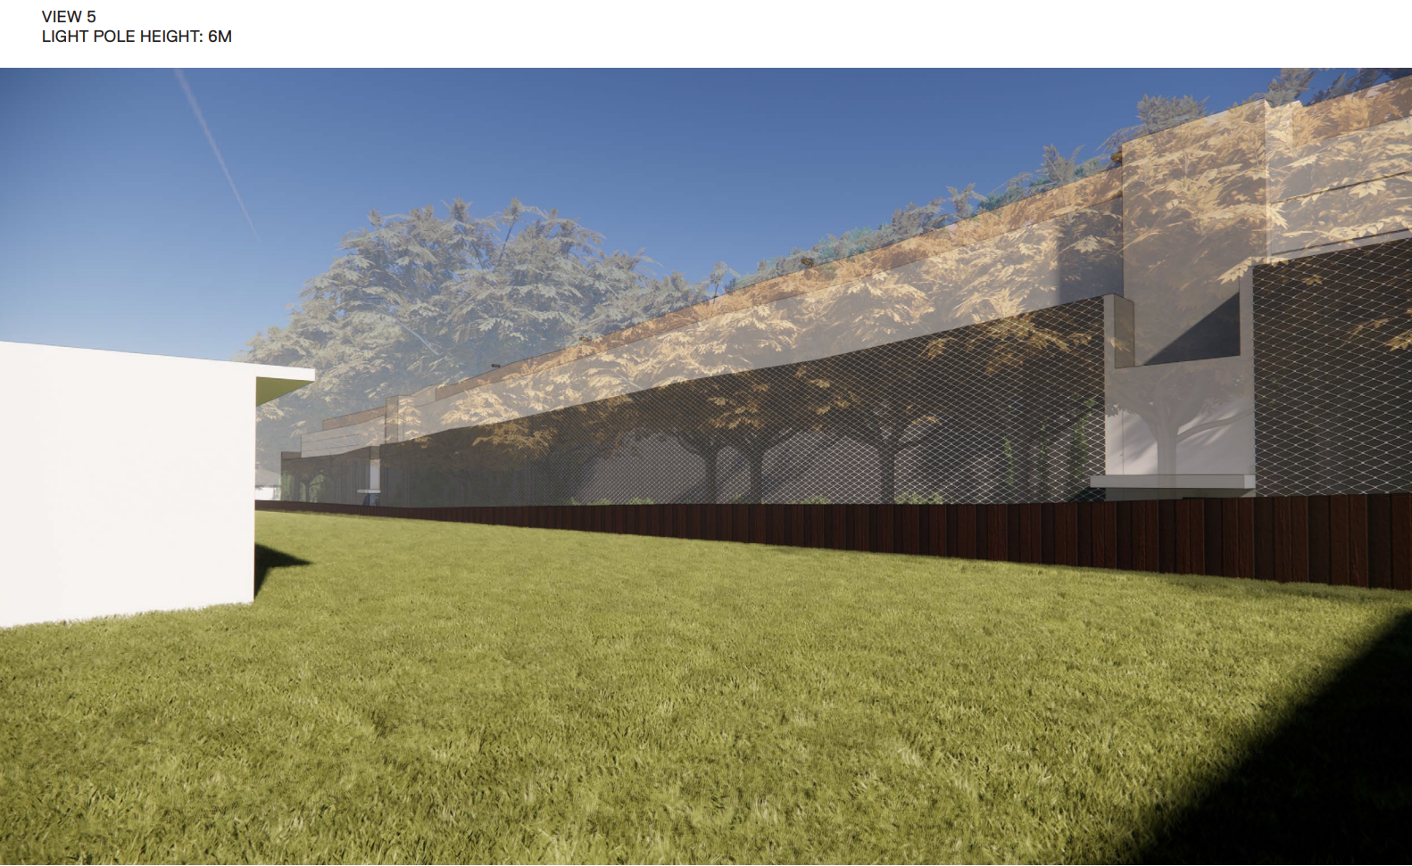

ATTACHMENT M – LANDSCAPE PLANS (2 PAGES)

LANDSCAPE MASTERPLAN:

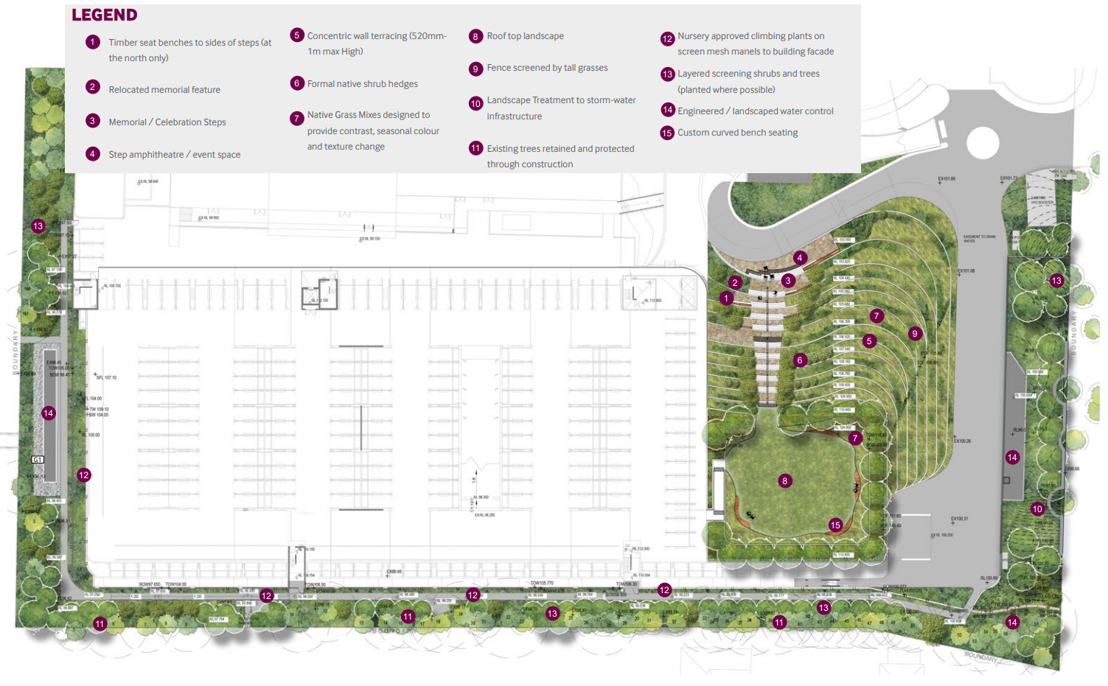

ENTRY PRECINCT LANDSCAPE PLAN:
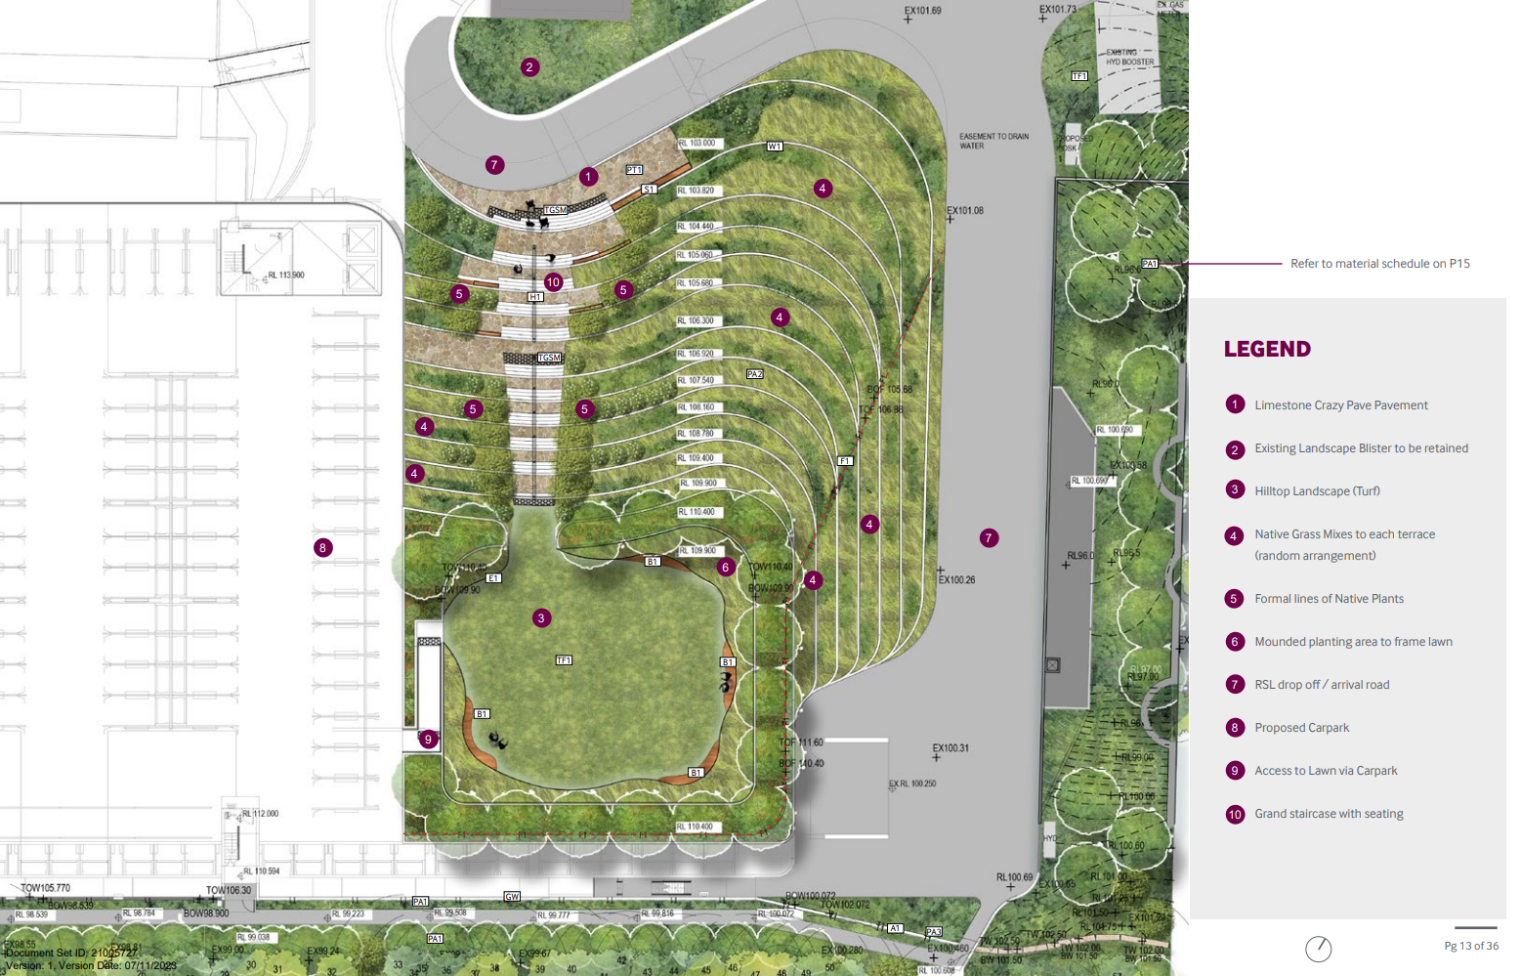

DEEP SOIL SECTION:
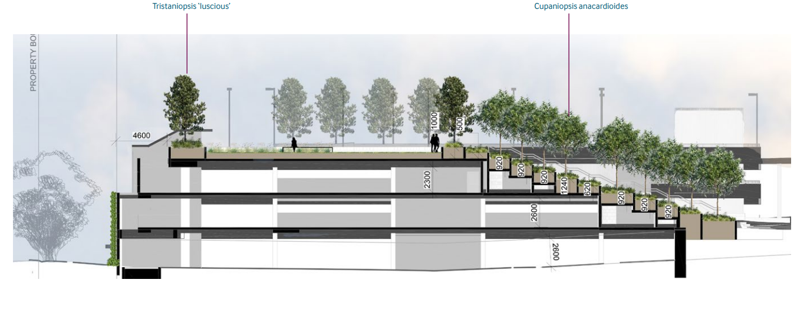
GREEN WALL EASTERN ELEVATION:
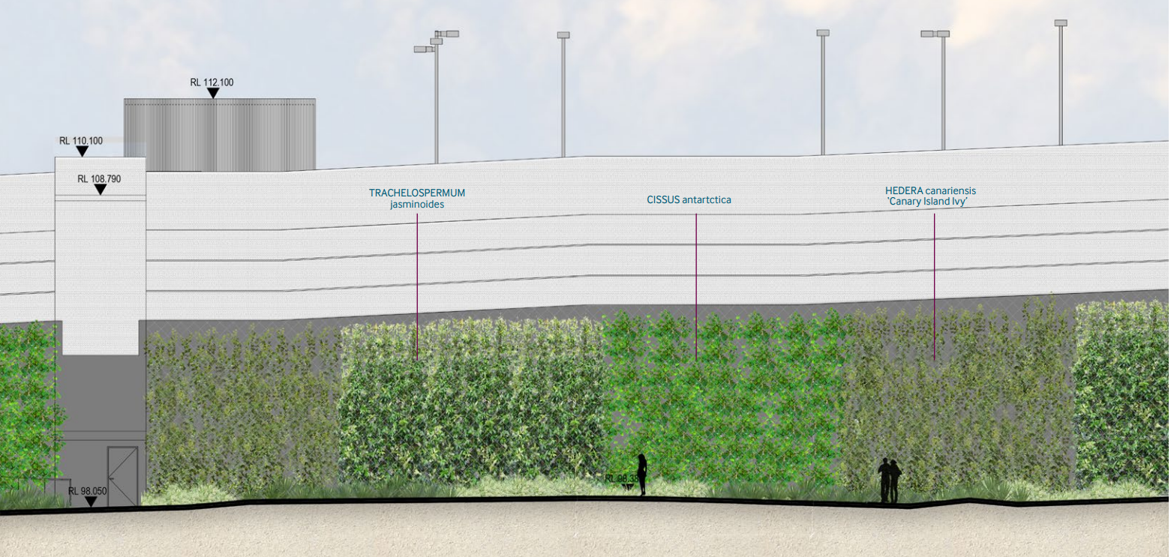

GREEN WALL SOUTHERN ELEVATION:
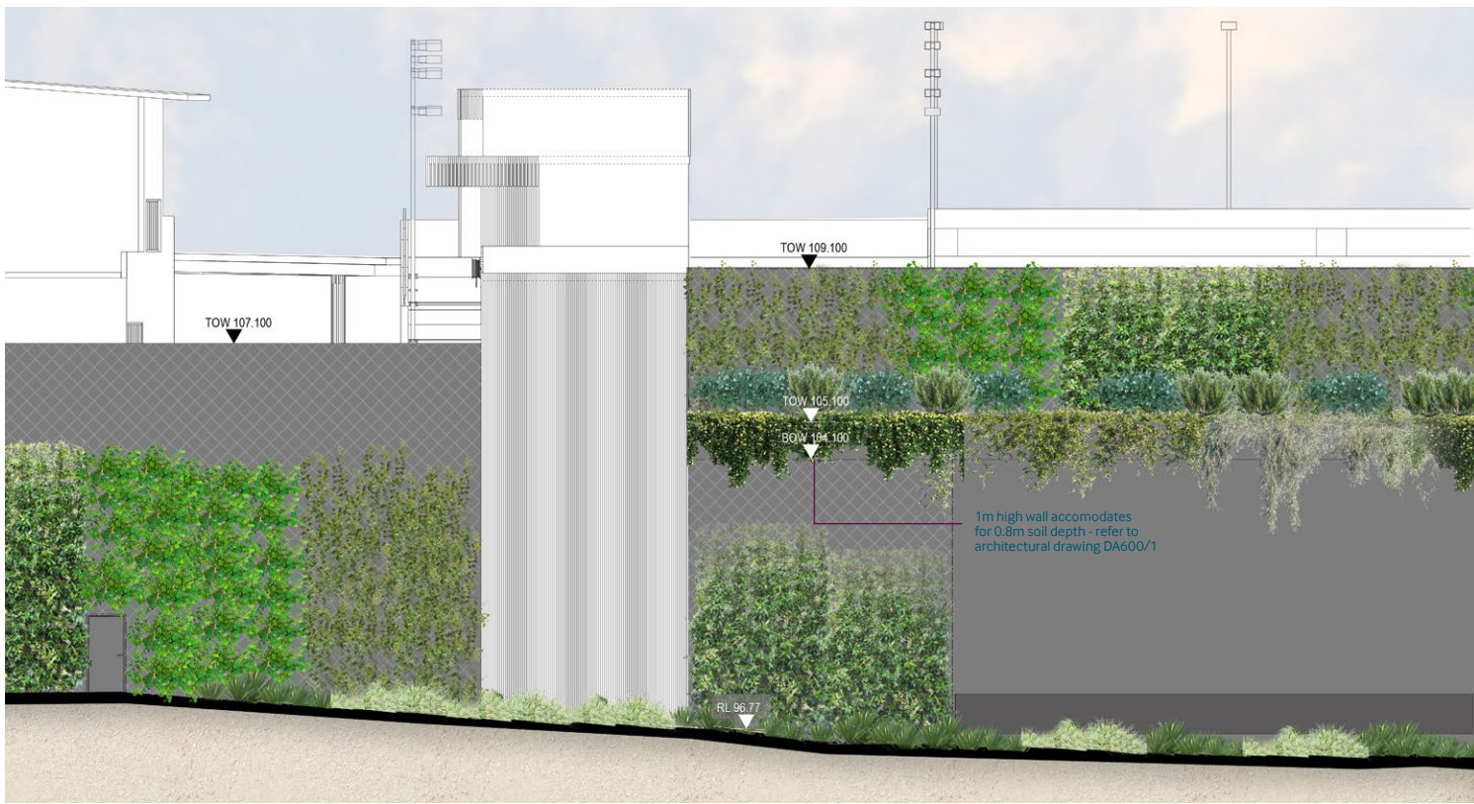
ATTACHMENT N – PERSPECTIVES (3 PAGES)

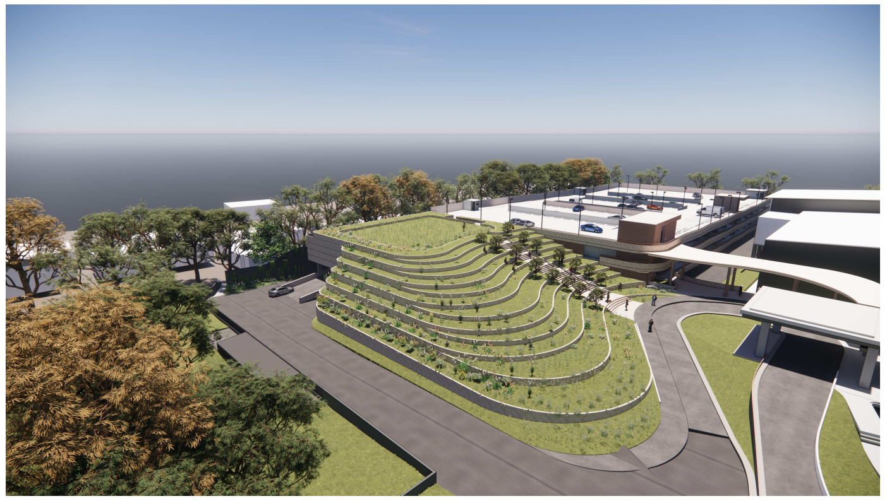

AMPITHEATRE:
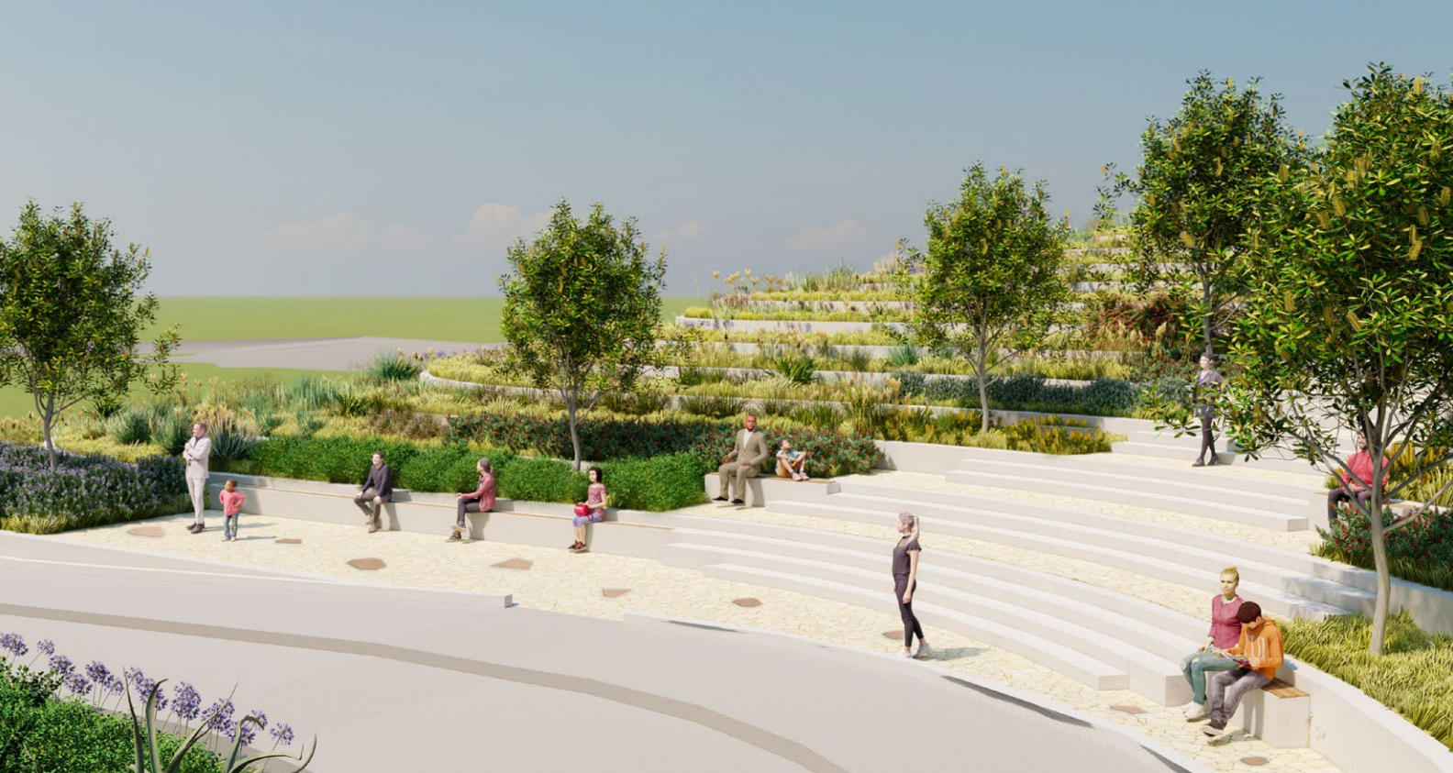

AMPITHEATRE:
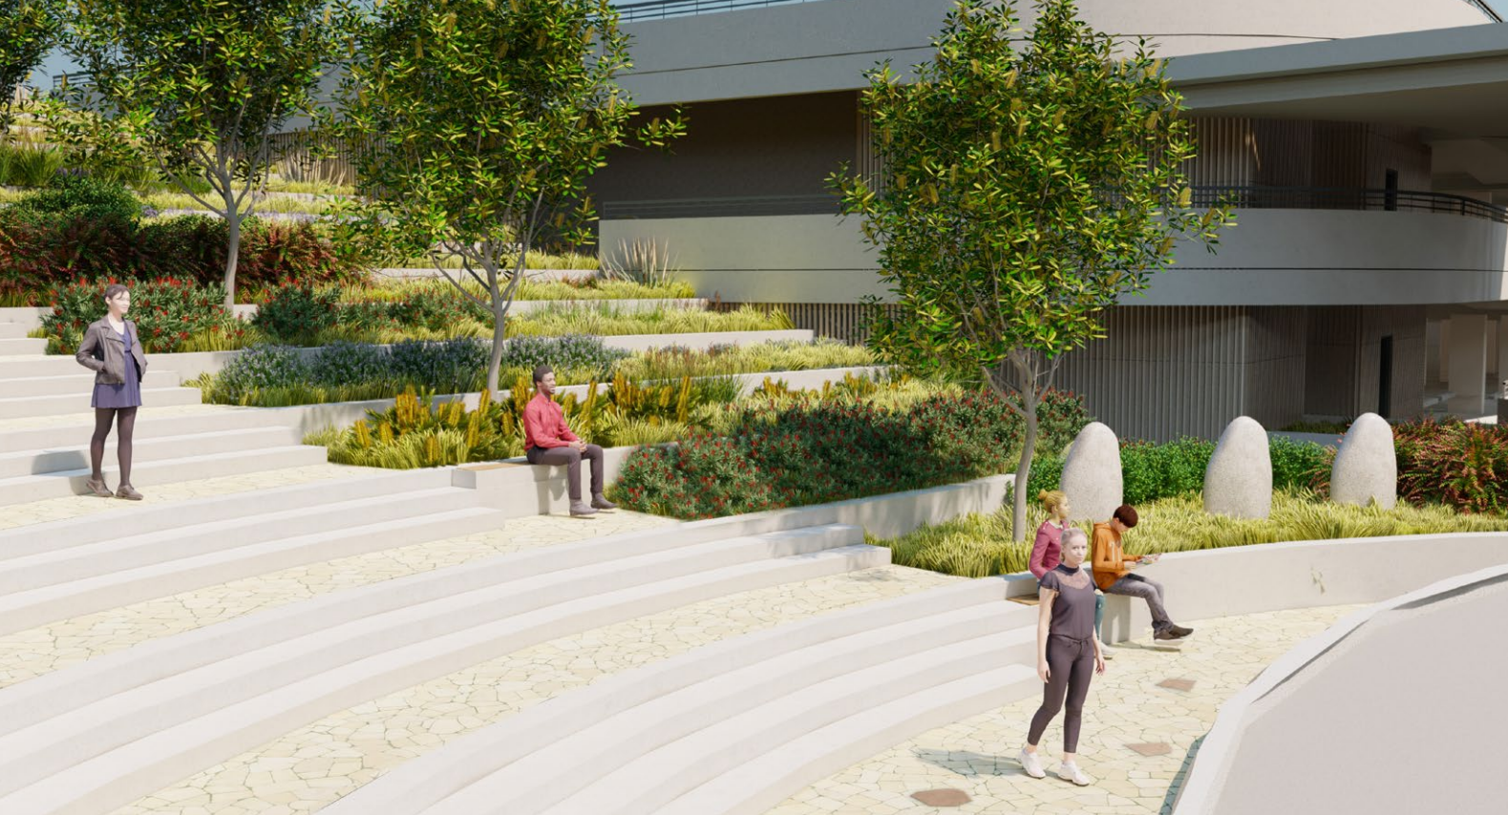

TERRACE SEATING:
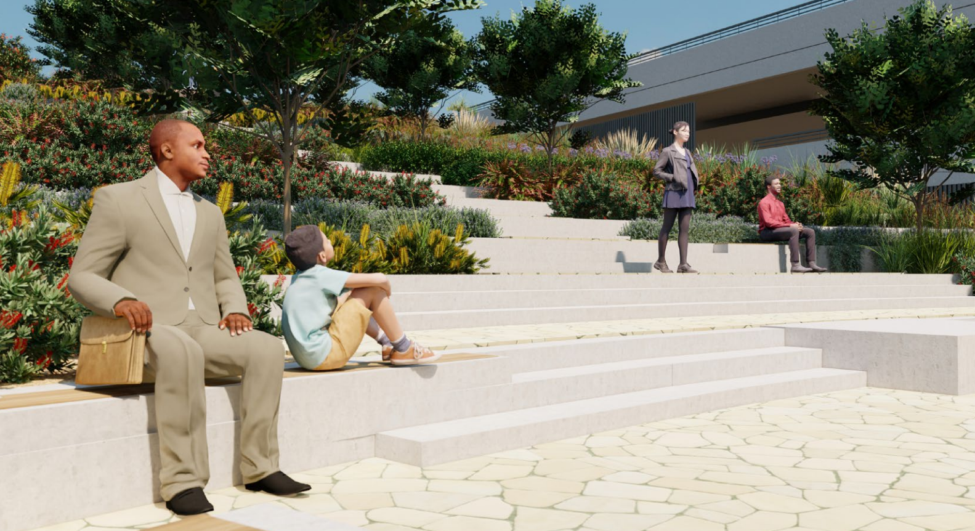

RELOCATED MEMORIAL:
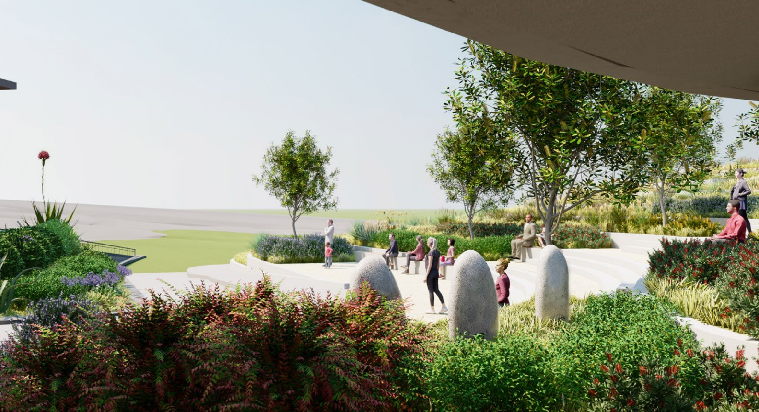

STAIRCASE:
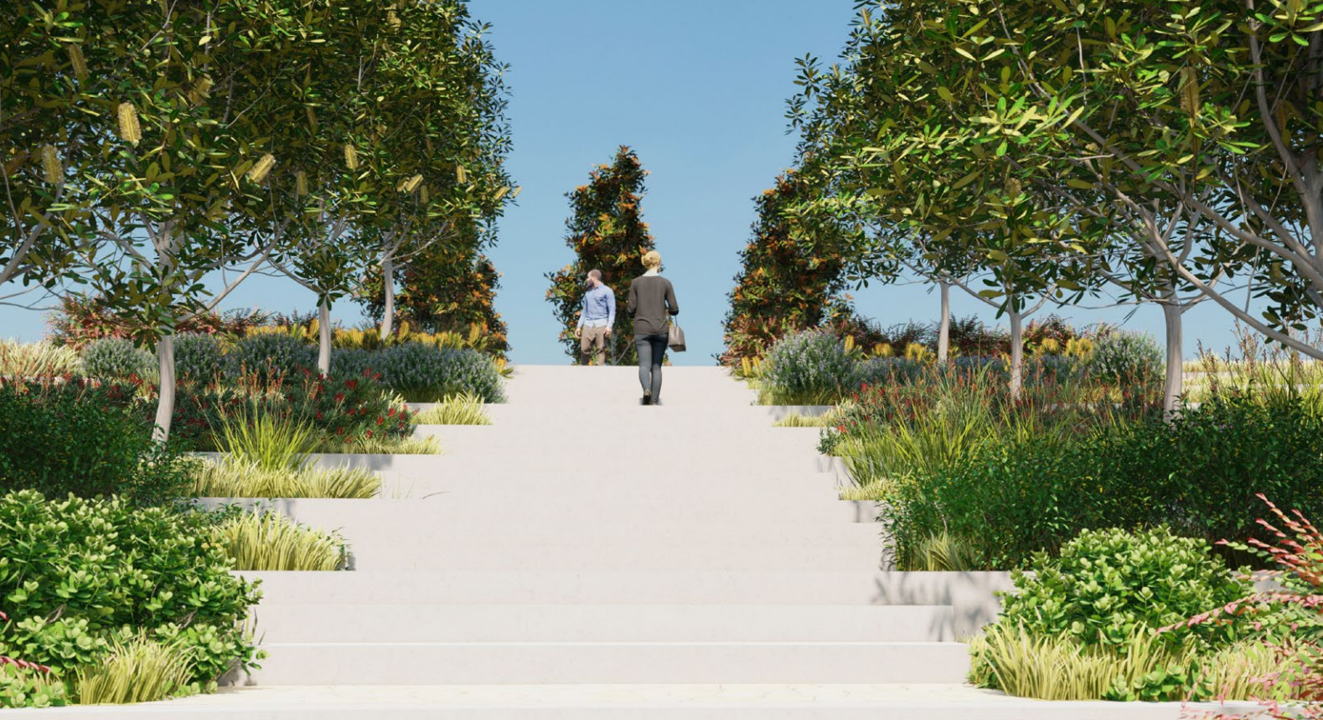

ATTACHMENT O – CONCILATION CONFERENCE NOTES (5 PAGES)

